**LAB 8:**

**Q1:**

**Lockfile:**

The “lockfile” command is used to create semaphore files, which can be used to indicate that a particular resource is in use or locked.

Example:  
 lockfile /tmp/mylockfile

**Cksum:**

The “cksum” command calculates a checksum for a file using a CRC (Cyclic Redundancy Check) algorithm.

Example:

cksum myfile.txt

**Comm:**

The “comm” command is used to compare two sorted files line by line.

Example:

comm file1.txt file2.txt

**Csplit:**

The “csplit” command splits a file into sections based on context lines.

Example:

csplit myfile.txt '/pattern/' {*}

**Chattr:**

The “chattr” command is used to change file attributes on a Linux file system, such as making a file immutable or setting it to be automatically compressed.

Example:

chattr +i myfile.txt

**Touch:**

The “touch” command is used to create an empty file or update an existing file's access and modification times.

Example:

touch newfile.txt

**PRACTICE:**

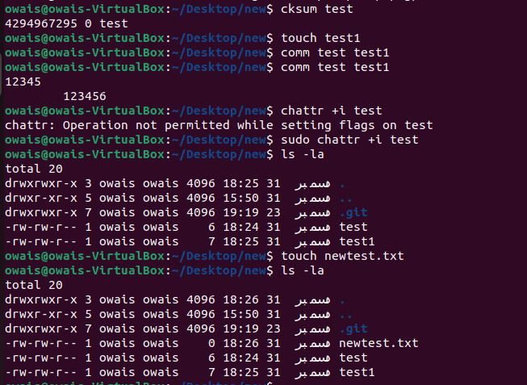

Q2:

1. The **cat** command is used to concatenate and display the content of files. In this case, it displays the content of the file named” **ch1**”.
2. This command concatenates the contents of three files (**ch1**, **ch2**, and **ch3**) and redirects the combined output to a new file named "your-practical-group."
3. This command appends the content of the file **note5** to the end of the file named **Notes**. Without overwriting the existing content.
4. This command allows you to input text interactively, and it will be written to the file named **temp1**. It's a way to create or edit a file directly from the command line. After entering this command, you can type text, and when you press **Ctrl + D**, the input will be saved to the file **temp1**.
5. This is similar to the previous command, but it uses a "here document" to input multiple lines of text, terminated by a specific delimiter ("yourname" in this case), and writes them to the file **temp2**.

Q3:

**CPIO**:

The **cpio** command is used for creating or extracting cpio archive files. It is often used in combination with the **find** command to archive and extract files based on certain criteria.

**SORT**:

The **sort** command is used to sort the lines of a text file or the output of a command. It can perform numeric or lexicographic sorting.

**Fuser**:

The **fuser** command is used to identify processes that are using a particular file, directory, or socket.

**File**:

The **file** command is used to determine the type of a file. It examines the content of a file and provides information about its type, such as whether it is a text file, binary file, or a specific type of data file.

Q4:

The “**-z**” option in the “**tar**” command is used to compress or decompress the archive using gzip. When creating an archive (**tar czvf**), it compresses the files, and when extracting an archive (**tar xzvf**), it decompresses the archive using gzip.

**WHEN CREATING COMPRESSED ARCHIVE:**

“tar czvf archive.tar.gz directory/”

* **c**: Create a new archive.
* **z**: Compress the archive using gzip.
* **v**: Verbosely list the files processed.
* **f**: Archive file name follows.

**WHEN EXTRACTING COMPRESSED ARCHIVE:**

“tar xzvf archive.tar.gz”

* **x**: Extract files from an archive.
* **z**: Decompress the archive using gzip.
* **v**: Verbosely list the files processed.
* **f**: Archive file name follows.

Q5:

**cp Command:**

The **cp** command is used to copy files or directories from one location to another.

**cpio Command:**

The **cpio** command is used for creating or extracting cpio archive files. It is often used in combination with other commands, such as **find**, to perform complex archiving operations.

Q7:

“**777**” gives full read, write, and execute permissions to the owner, group, and others.

“**775**” gives full read, write, and execute permissions to the owner and group, but only read and execute permissions to others.